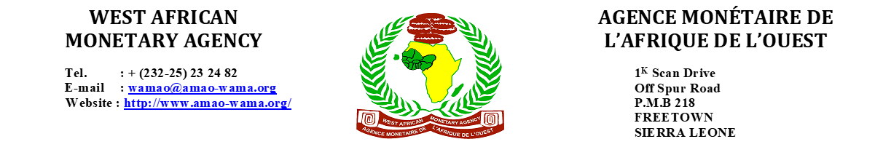

**Advertisement for the Position of Information Technology Officer**

The West African Monetary Agency (WAMA) is an autonomous and specialised body of ECOWAS. It was established in 1993, and started operations in 1996, as result of the transformation of the West African Clearing House (WACH). The Agency is charged with the responsibility for monitoring, coordinating, and implementing the ECOWAS Single Monetary Cooperation Programme (EMCP), geared towards the creation of the ECOWAS single currency. WAMA is seeking applications from experienced individuals for the position of Information Technology (IT) Officer at Grade P2.

|  |  |
| --- | --- |
| **Position** | **IT OFFICER, P2** |
| **Department** | IT Unit (responsible for implementing and maintaining the Agency information and communication infrastructure and solutions that support its work). |
| **Job Description** | Within the framework of delegated authorities, the Information Technology Officer may be responsible for the following tasks:   1. Manage projects involving feasibility studies, systems analyses, design, development, and implementation of new systems; 2. Develop detailed and other functional specifications and user documentation for key systems; 3. Provide expert advice to users, analyse their needs and translate them into system specifications or applications; 4. Analyse staff needs, identify vulnerabilities, and use the findings to prepare the IT budget; 5. Implement and maintain IT infrastructure comprising physical, virtual and cloud networks in ways that optimise performance; 6. Implement applications and software upgrades, as well as IT security to prevent a systemwide cybersecurity breach or minimise its effect in case it should occur; 7. Maintain, upgrade or improve existing infrastructure; 8. Troubleshoot and provide ongoing support to users as well as advising on the use of new technologies; 9. Study or monitor system events/logs to identify root causes of issues and resolve or anticipate potential issues; 10. Maintain the Agency website; 11. Develop training materials, operating manuals, and train staff in assigned systems; 12. Participate in developing disaster recovery plans and ensure appropriate planning and training of users; 13. Conduct research, analysis and evaluation of new technologies and make recommendations for their deployment; 14. Participate in the writing of reports and documents on topics related to systems, system requirements, information strategy, etc. 15. Manage IT contract administration, including the establishment of service level agreements with suppliers; 16. Supervise junior IT staff; 17. Implement and monitor daily backup and recovery procedure; and 18. Perform any other task that may be assigned by the Director General. |
| **Qualifications** | The candidate must hold a bachelor’s degree in computer science, information systems or computer engineering from a recognized University. He/She must have:   * A minimum of 5 years of progressively responsible experience in the planning, design, development, implementation, and maintenance of computer systems; * A minimum of 5 years of experience in complex system architecture; * A minimum of 5 years of experience in information and application security; * Experience in data center management methodology; * Experience in developing policies and guidelines for implementation is desirable; and * Good oral and written communication skills in either English or French. A working knowledge in the other language would be an added advantage. |
| **Personality Requirements** | The candidate is expected to produce high quality work under pressure with little to no supervision and demonstrate the ability to deal with sensitive issues in a multi-cultural environment and to build effective working relations with colleagues.  Must not be more than 45 years of age. |

**Salary is competitive.**

Interested candidates who qualify should forward application, credentials, and up-to-date CV to the below address, on or before **14th March, 2025**, between the hours of 08:30 am to 5:00 pm, Mondays to Fridays.

**The Director General**

**West African Monetary Agency**

**1K Scan Drive, Off Spur Road, Freetown**

**OR**

**Submit it by email to:** [**wamao@amao-wama.org**](mailto:wamao@amao-wama.org)

**WAMA is an equal opportunity employer, only shortlisted candidates will be contacted.**